Preparation before printing on Mac:

- Open desired file (e.g. a PDF). Click "File" and choose "Print". Select "Show Details"

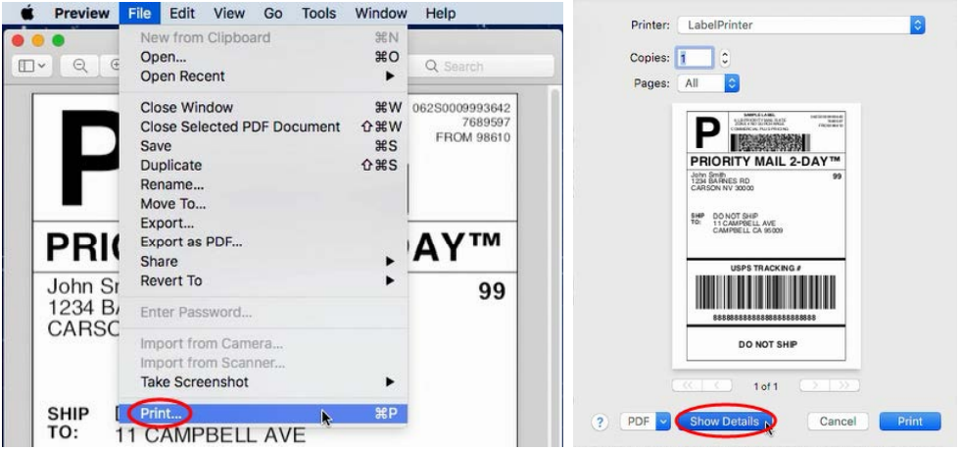
- Choose a paper size from "Paper Size".

If the size you need is not listed, then click "Manage Custom Sizes", input width and height, then click "OK".

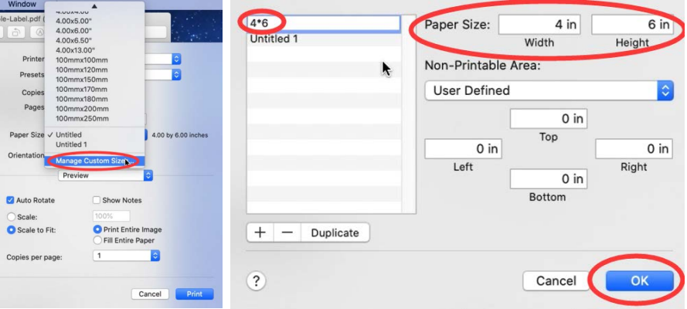

- Select "Printer Features" in "Preview", you can set up printer properties, such as "Media Tracking", "Darkness" and "Print speed".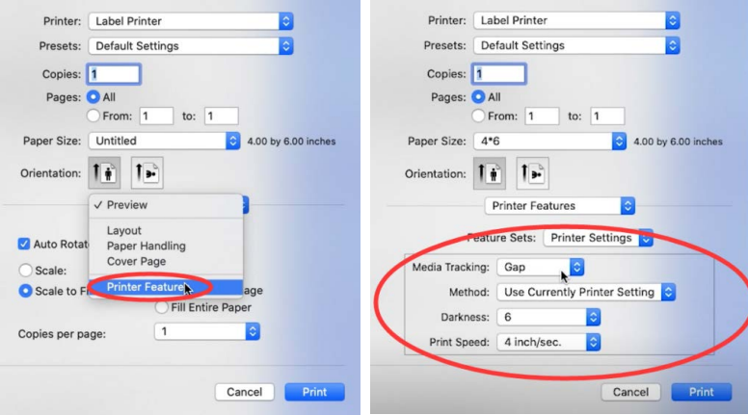
- Select a paper type in "Media Tracking". Choose from "Continuous", "Gap" or "Black Line".
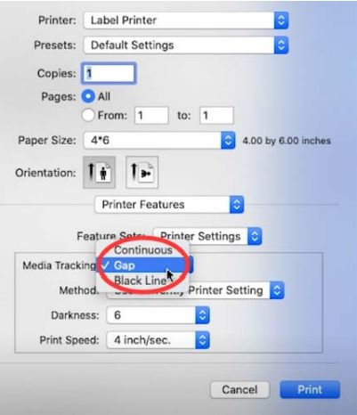

- You can change the printing speed and the Darkness of your printing (A larger number means higher Darkness)

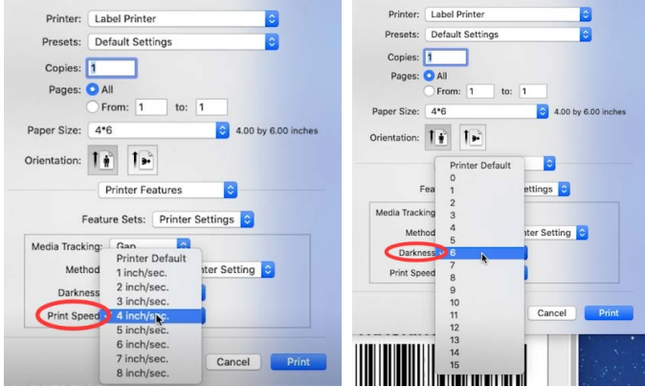

- After setup, click "Print"
